**מלישס**

11390975

file 11390975: Average machine count per day is: 3.167file 11390975: Standard deviation is: 7.445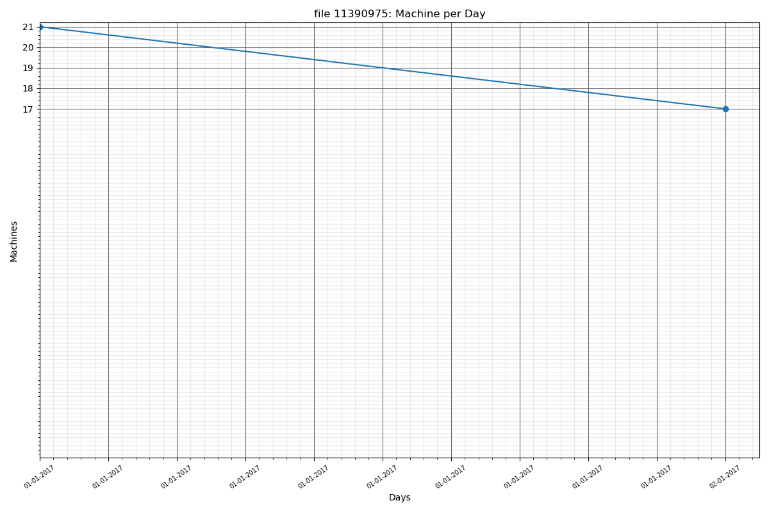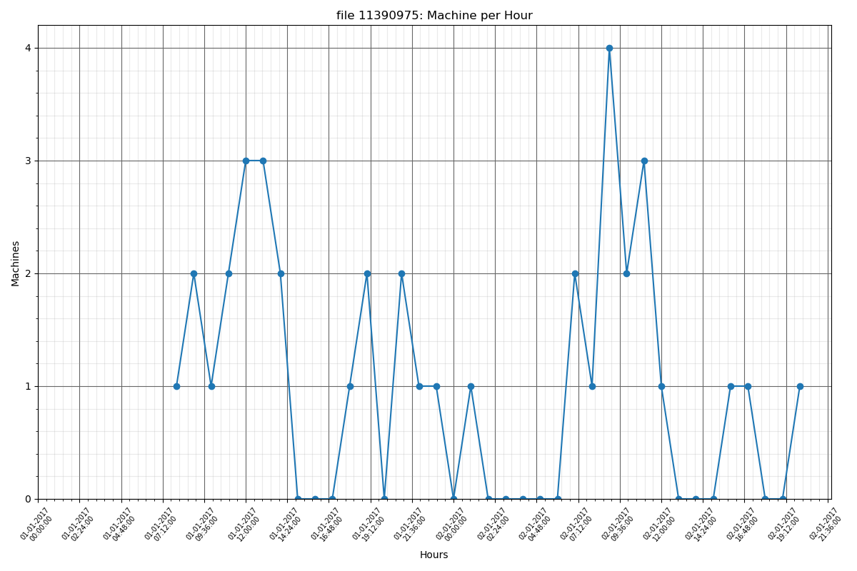

2254774

file 2254774: Average machine count per day is: 1.000

file 2254774: Standard deviation is: 2.663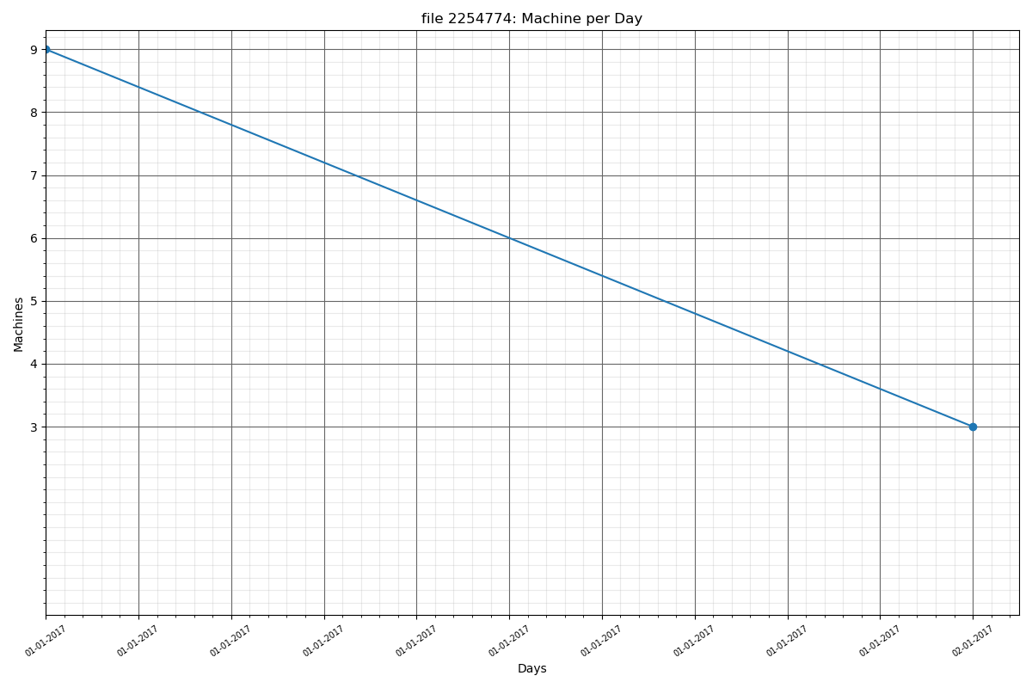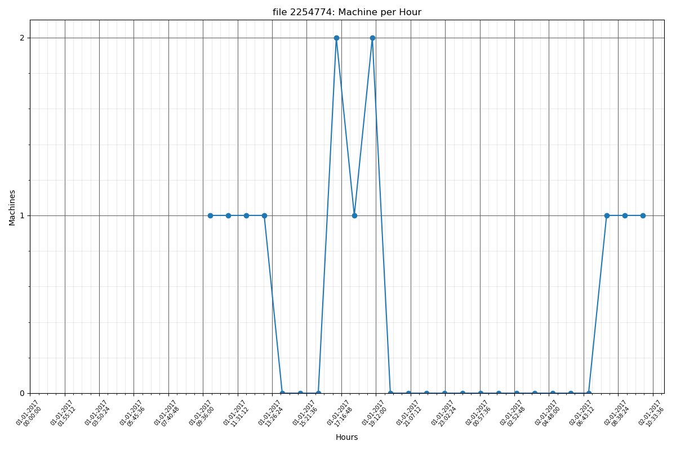

6748591

file 6748591: Average machine count per day is: 1.917

file 6748591: Standard deviation is: 4.719

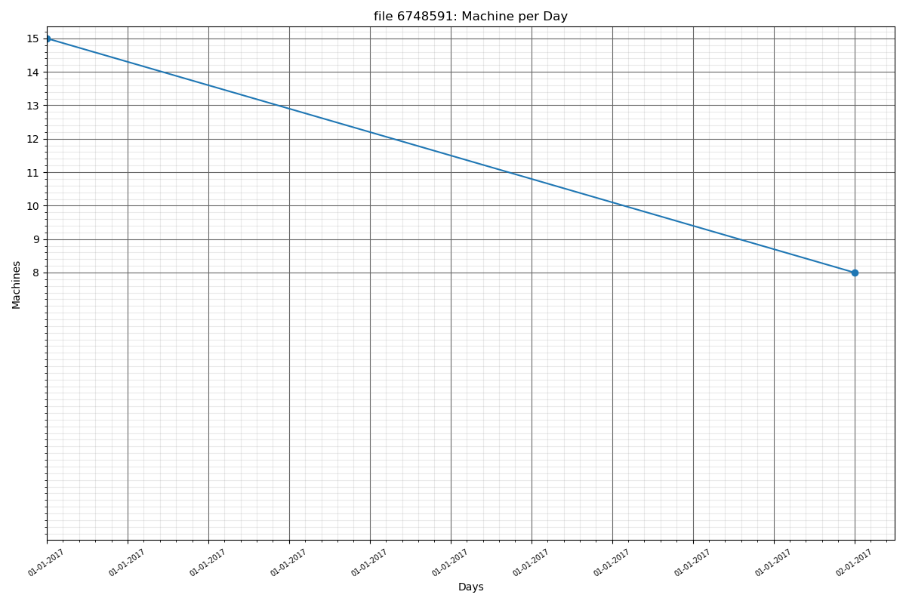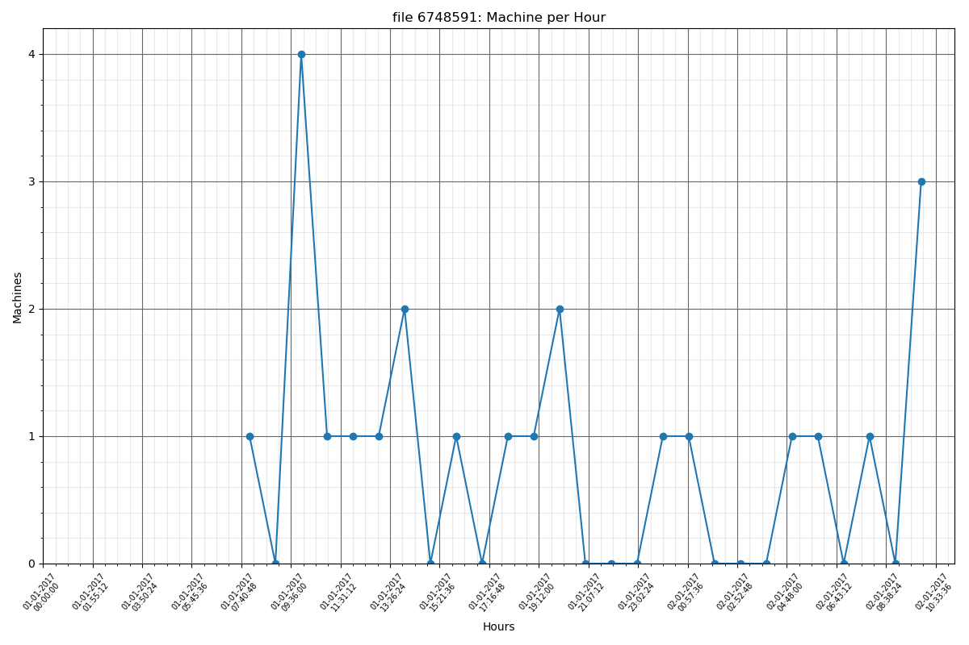

1325920

file 1325920: Average machine count per day is: 0.750

file 1325920: Standard deviation is: 1.765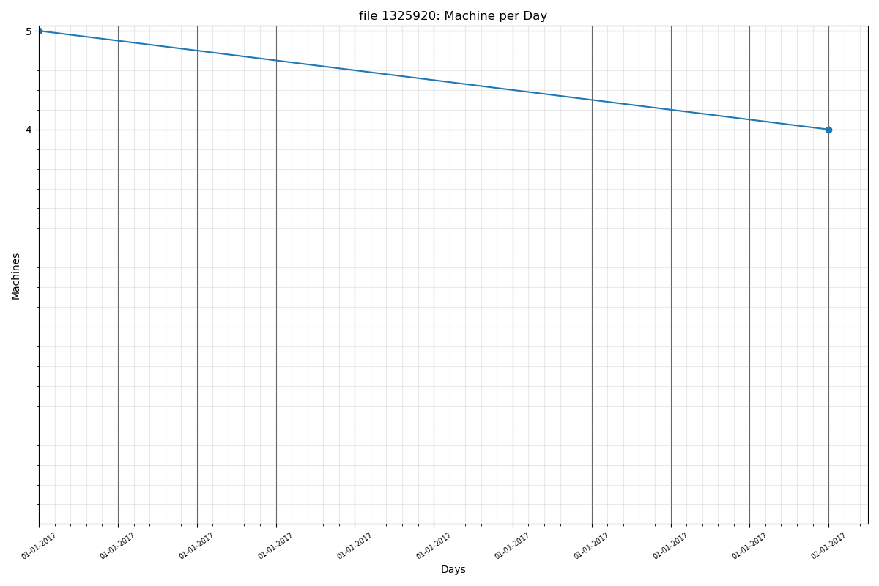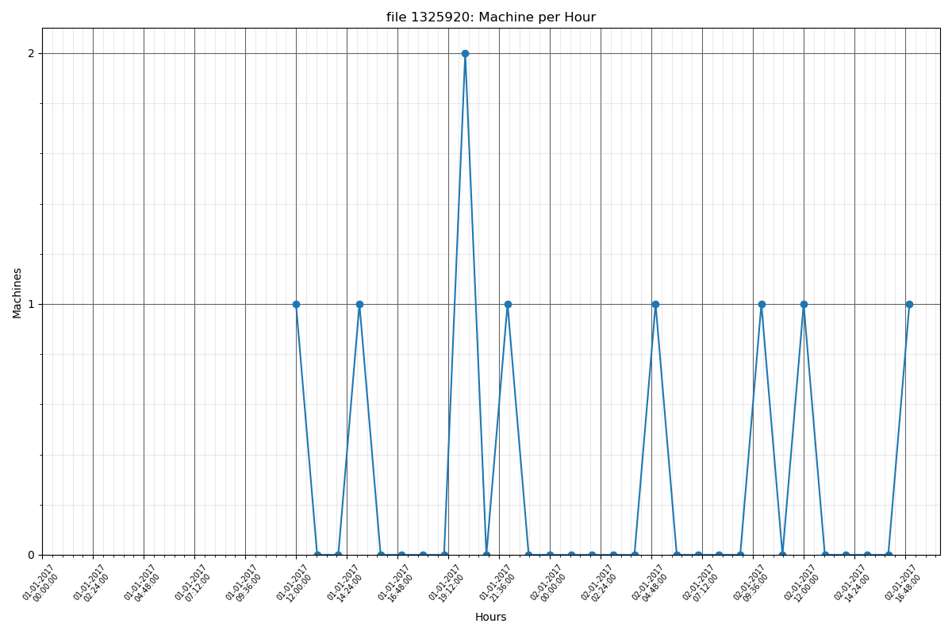

1212281

file 1212281: Average machine count per day is: 0.500

file 1212281: Standard deviation is: 1.243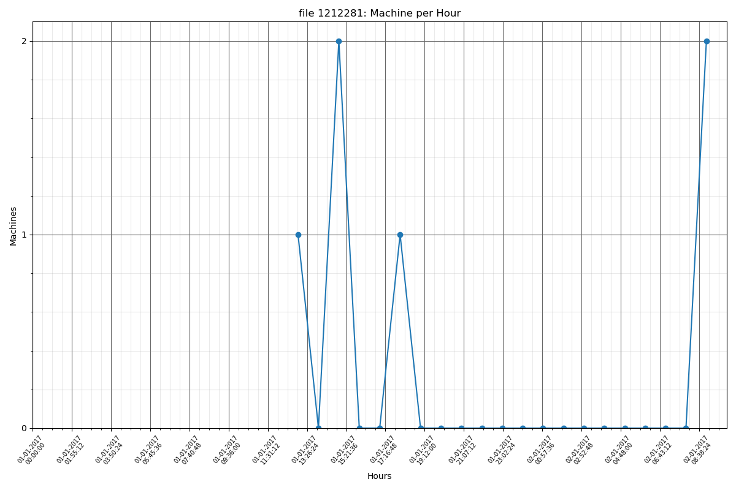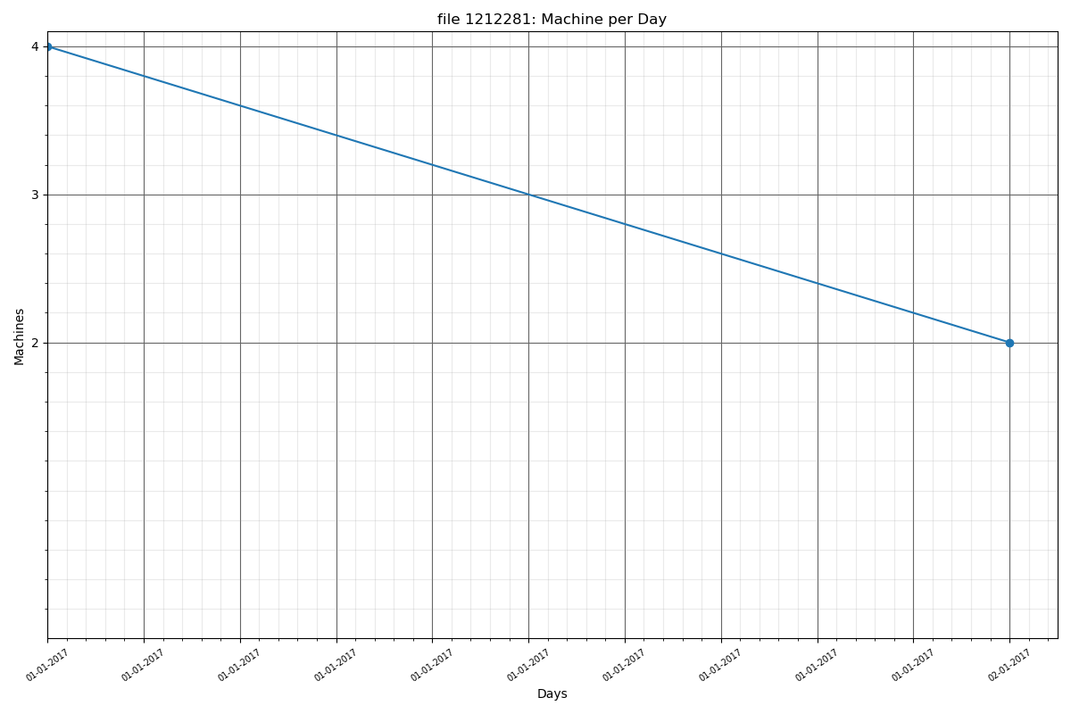

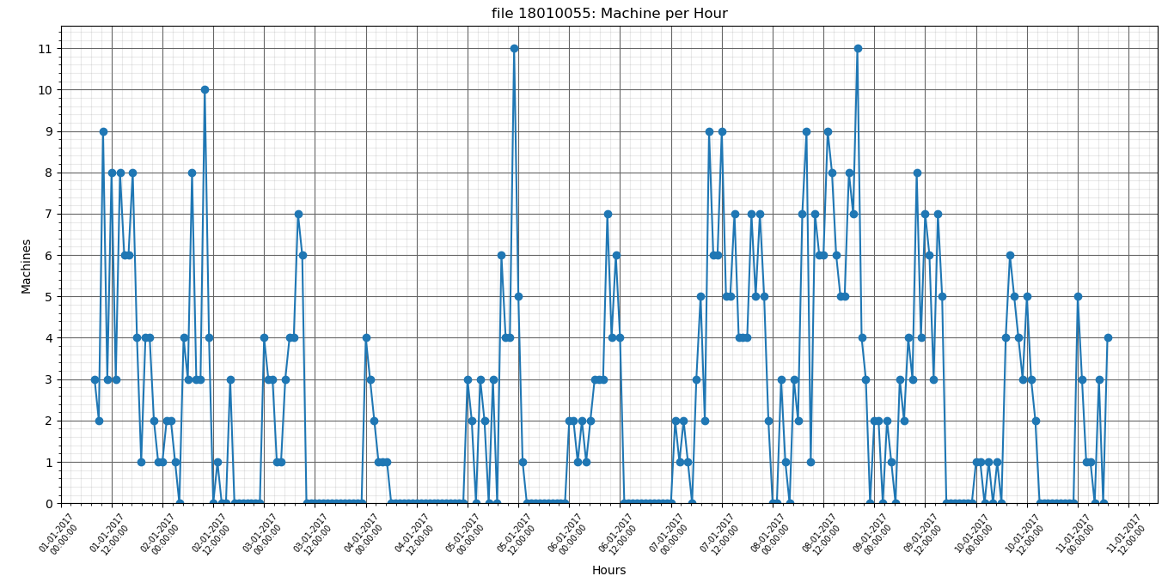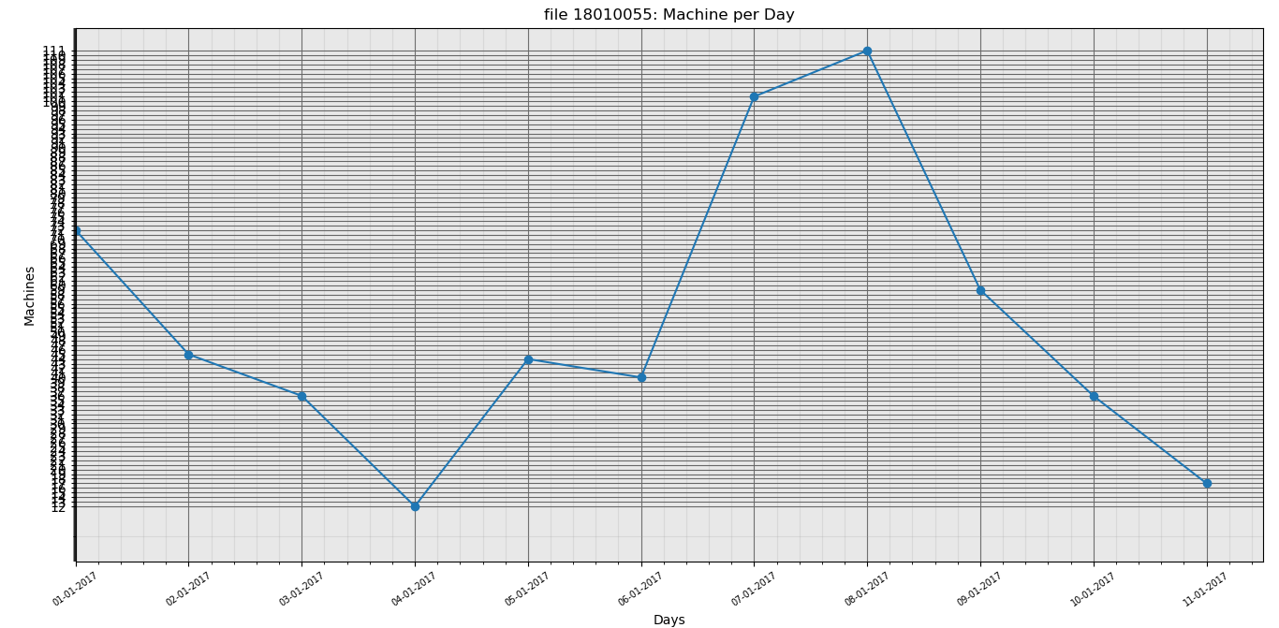

**file 18010055: Average machine count per day is: 47.750**

**file 18010055: Standard deviation is: 33.591**

**12189042**

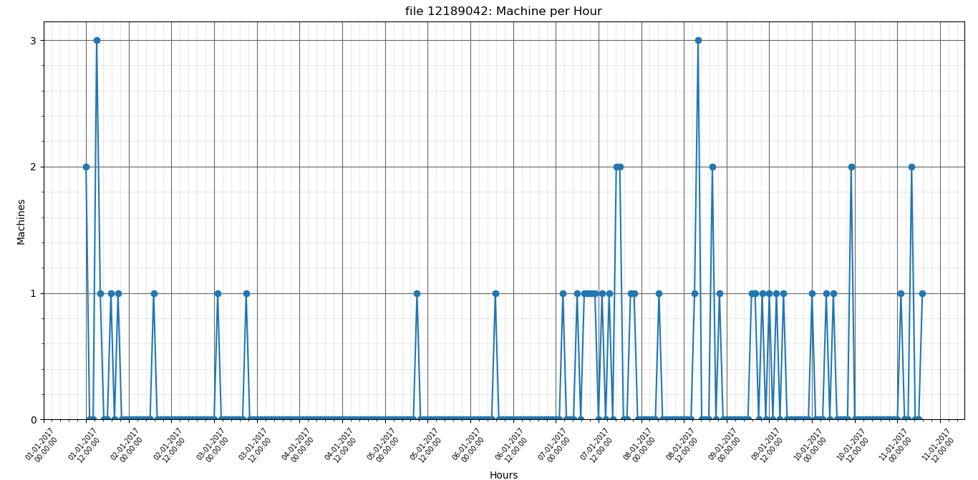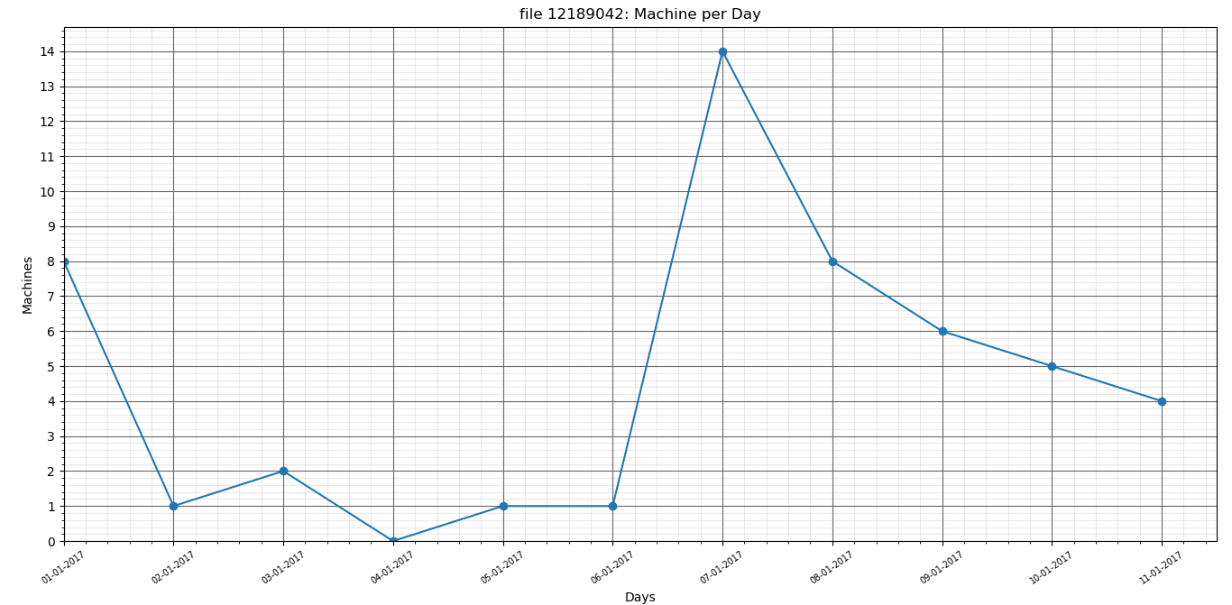

**file 12189042: Average machine count per day is: 4.167**

**file 12189042: Standard deviation is: 4.260**

**2202547**



**file 12189042: Average machine count per day is: 4.167**

**file 12189042: Standard deviation is: 4.260**

**5001896**

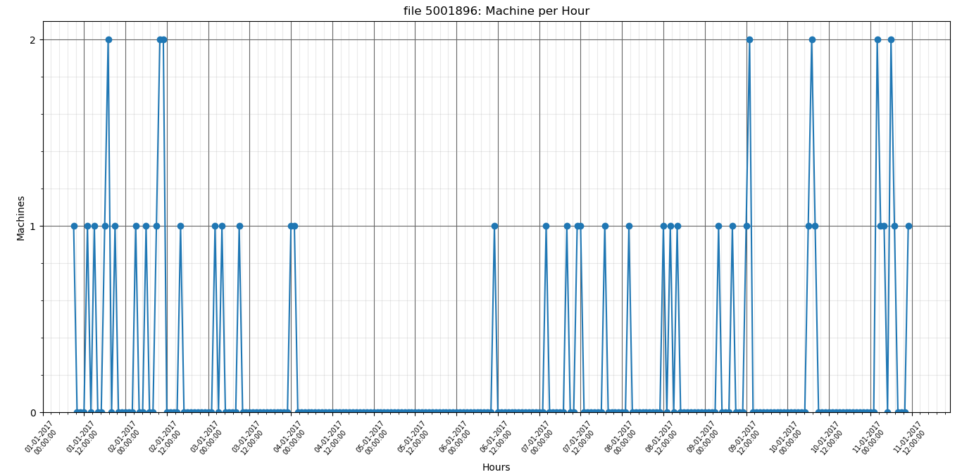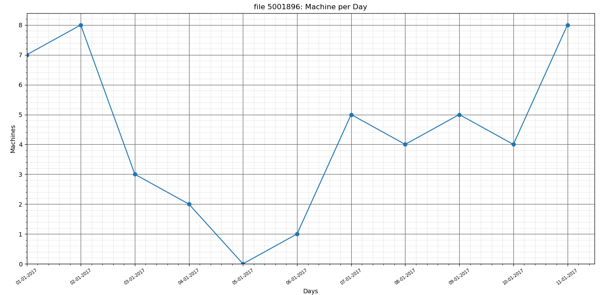

**file 5001896: Average machine count per day is: 3.917**

**file 5001896: Standard deviation is: 2.843**

**4676898**

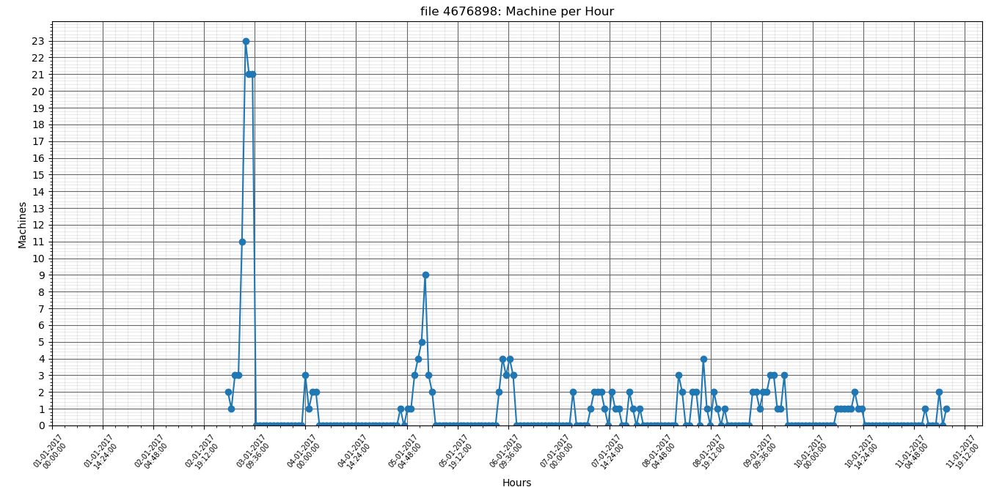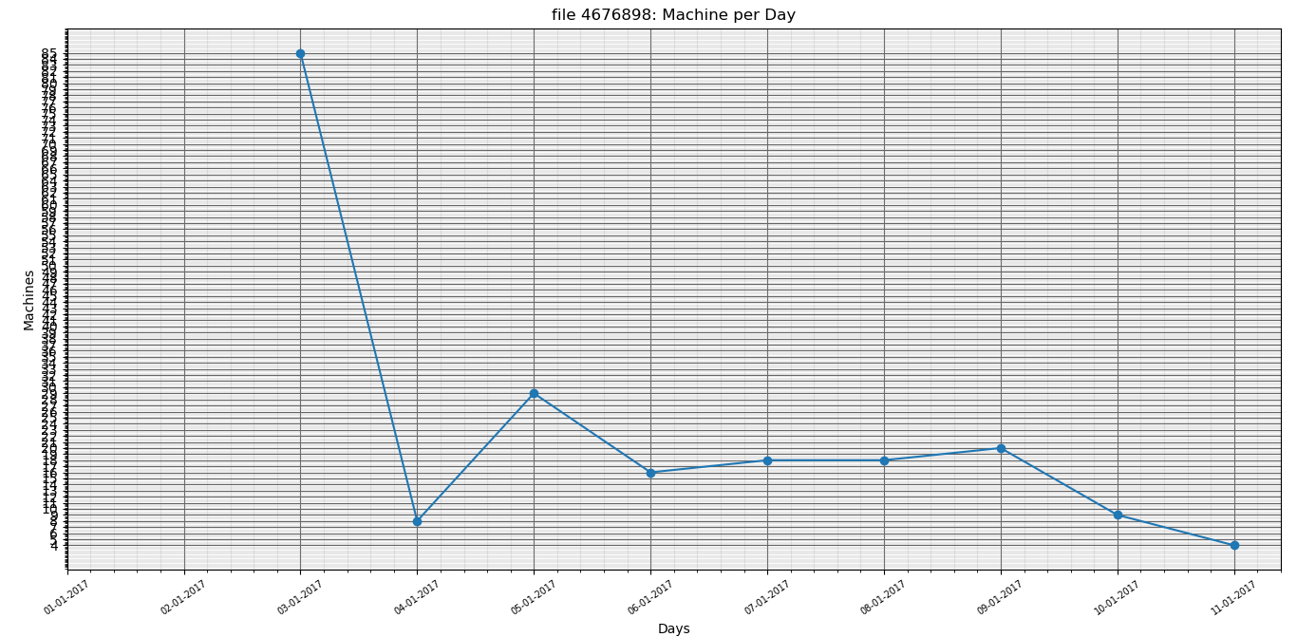

**file 4676898: Average machine count per day is: 17.250**

**file 4676898: Standard deviation is: 23.277**

**9717952**

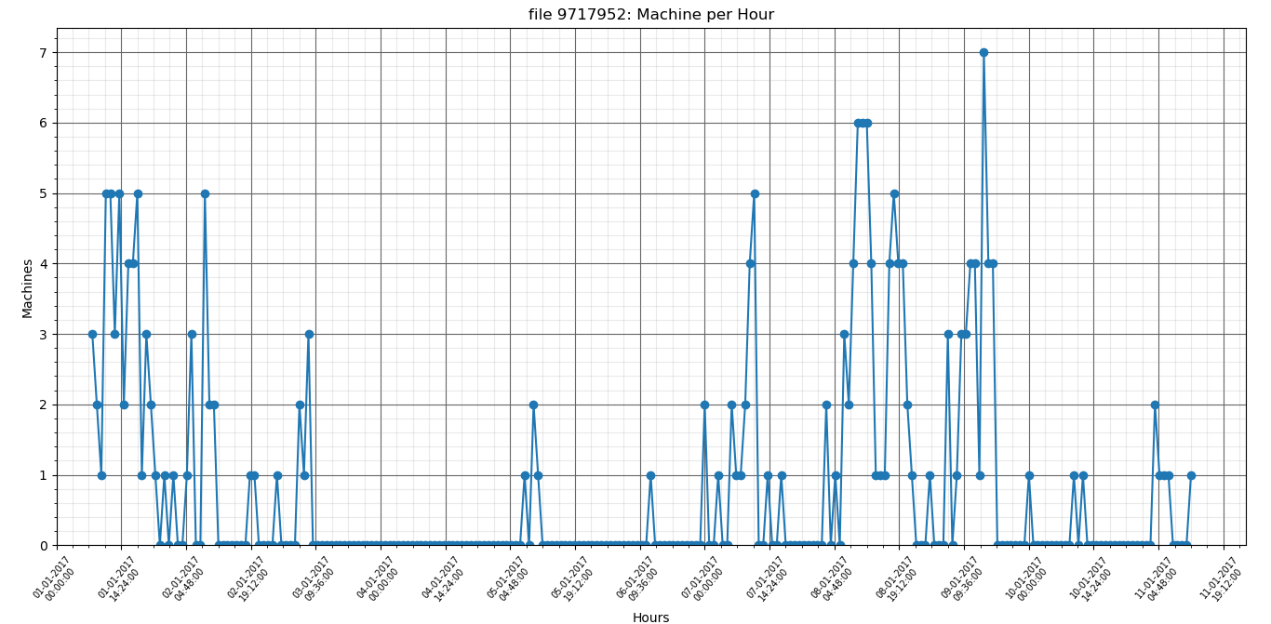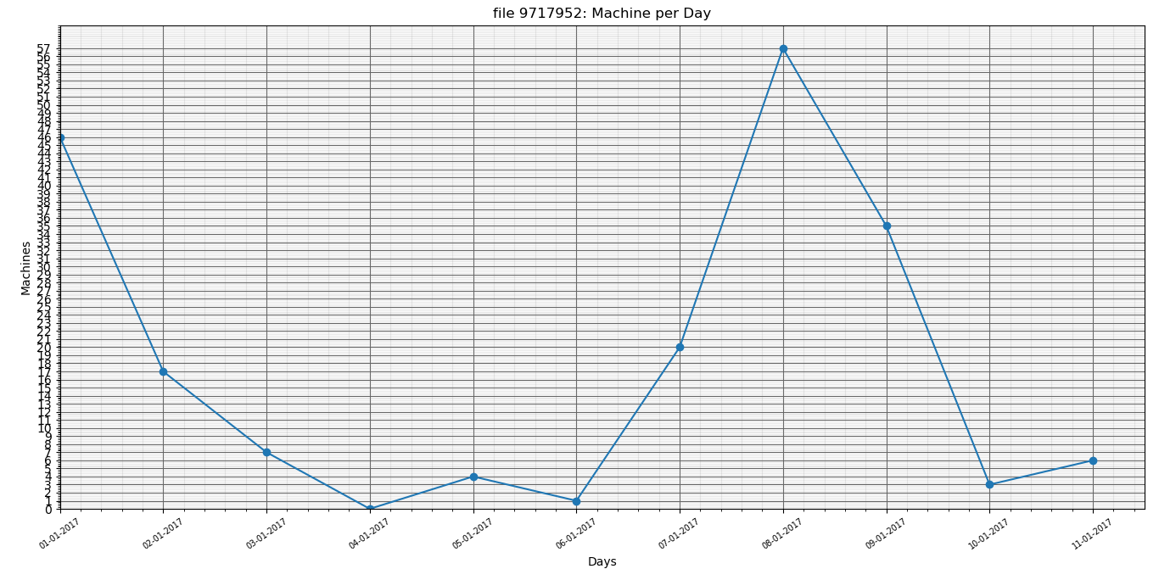

**file 9717952: Average machine count per day is: 16.333**

**file 9717952: Standard deviation is: 19.514**

**3601950**

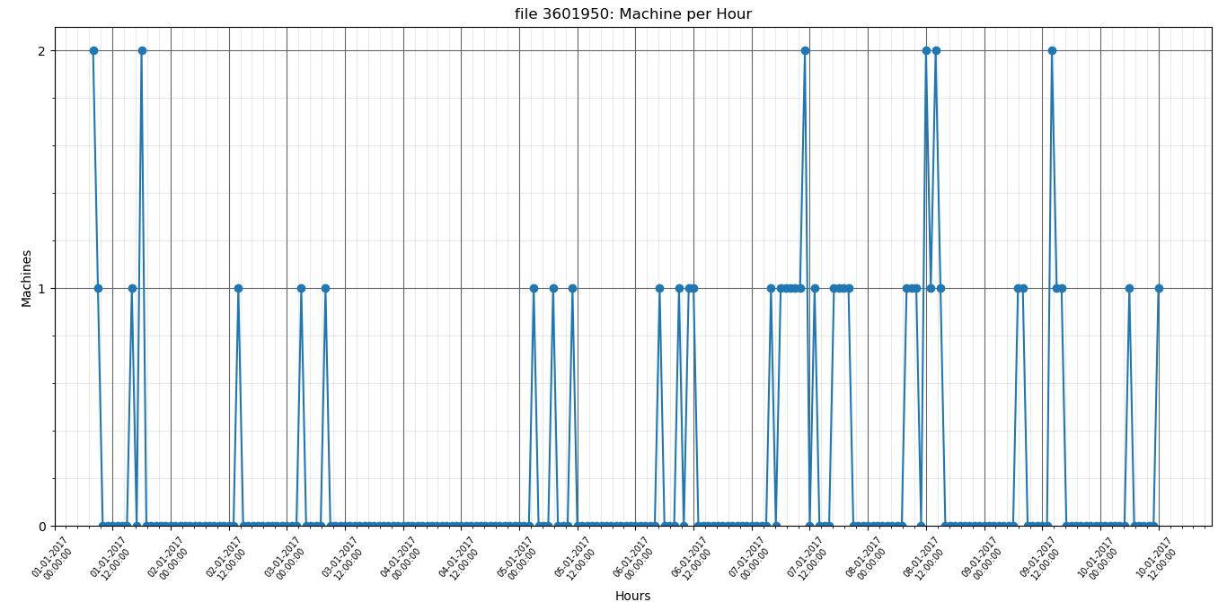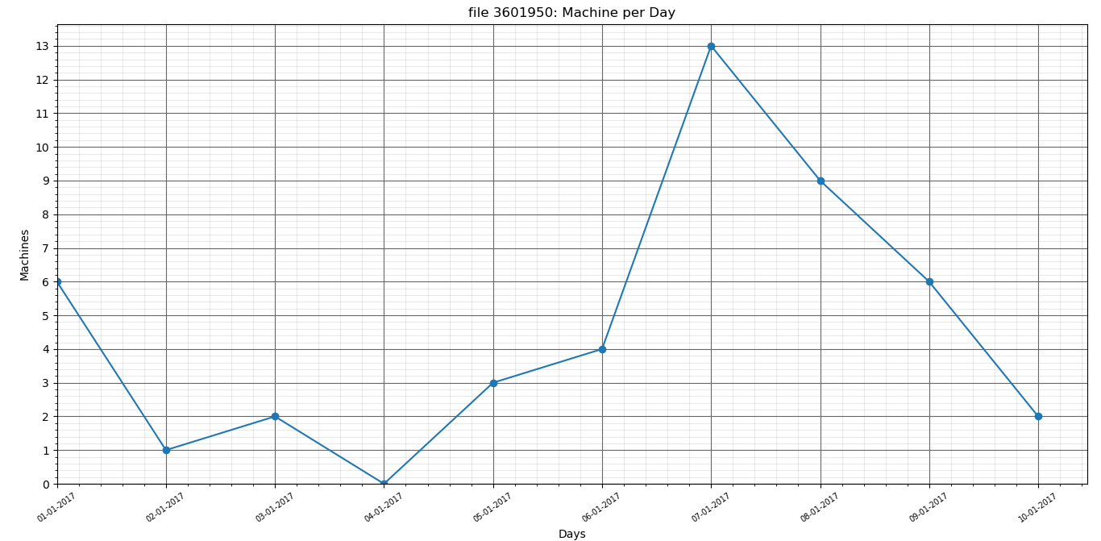

**file 3601950: Average machine count per day is: 3.833**

**file 3601950: Standard deviation is: 4.041**

**6637411**

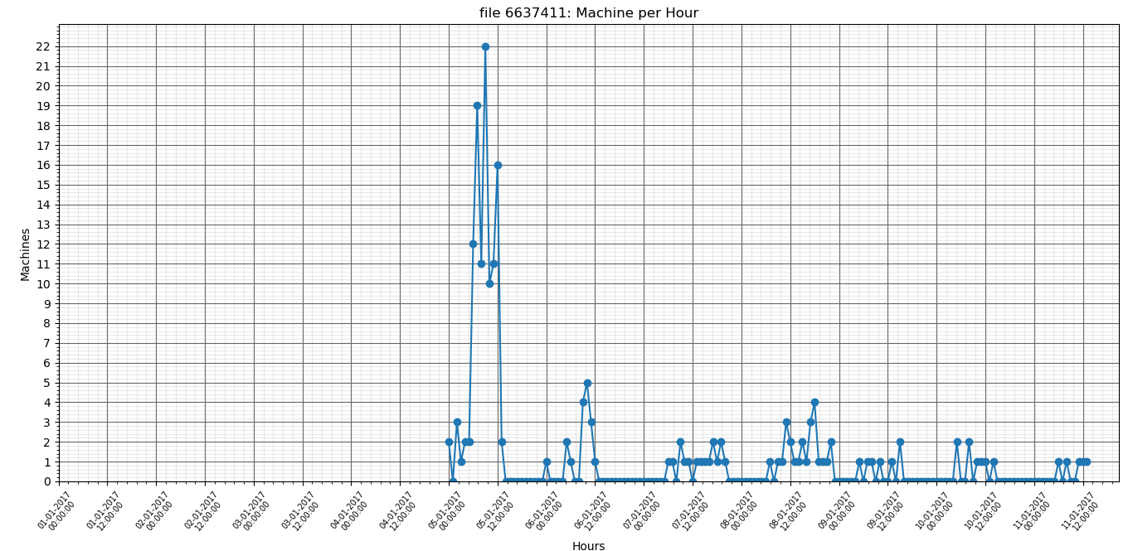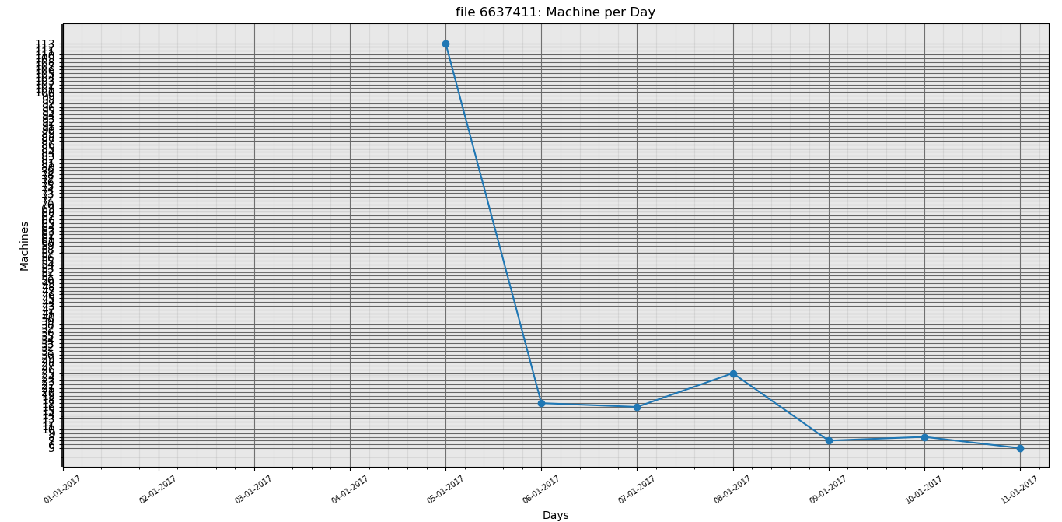

**file 6637411: Average machine count per day is: 15.917**

**file 6637411: Standard deviation is: 31.676**

**6662643**

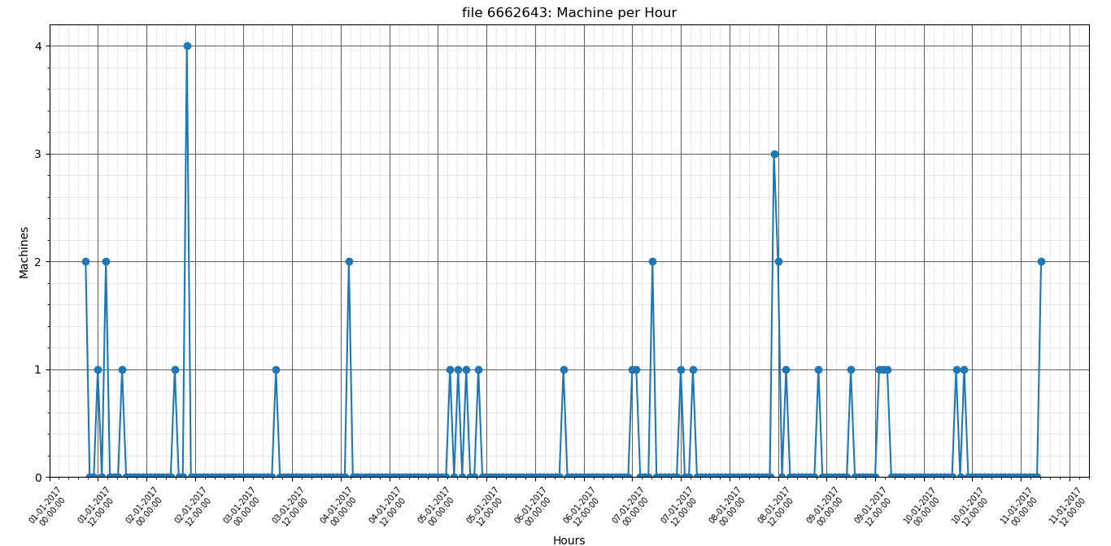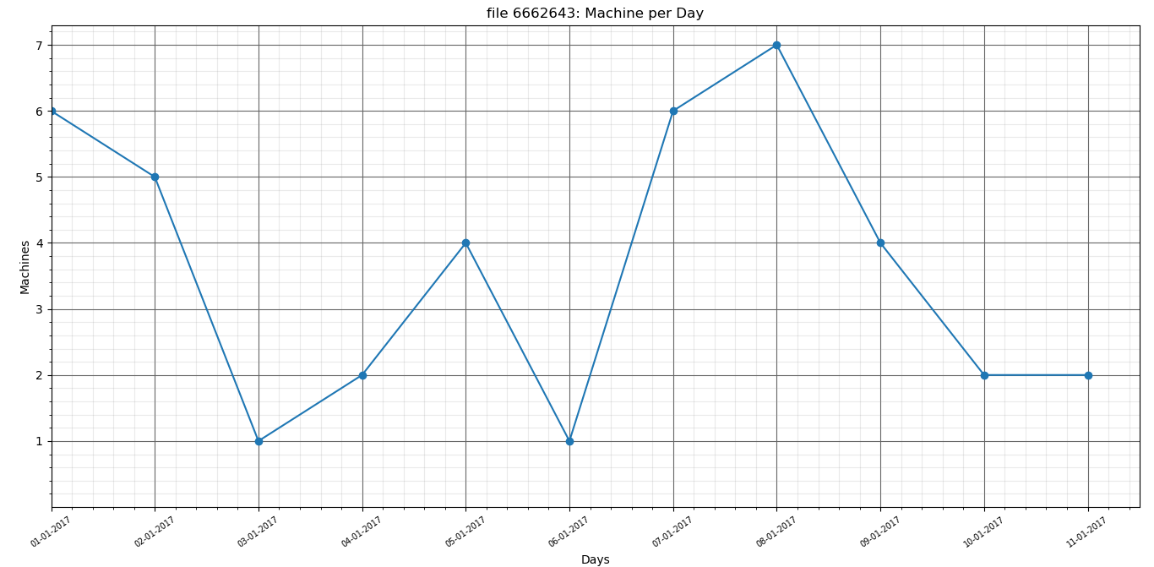

**file 6662643: Average machine count per day is: 3.333**

**file 6662643: Standard deviation is: 2.309**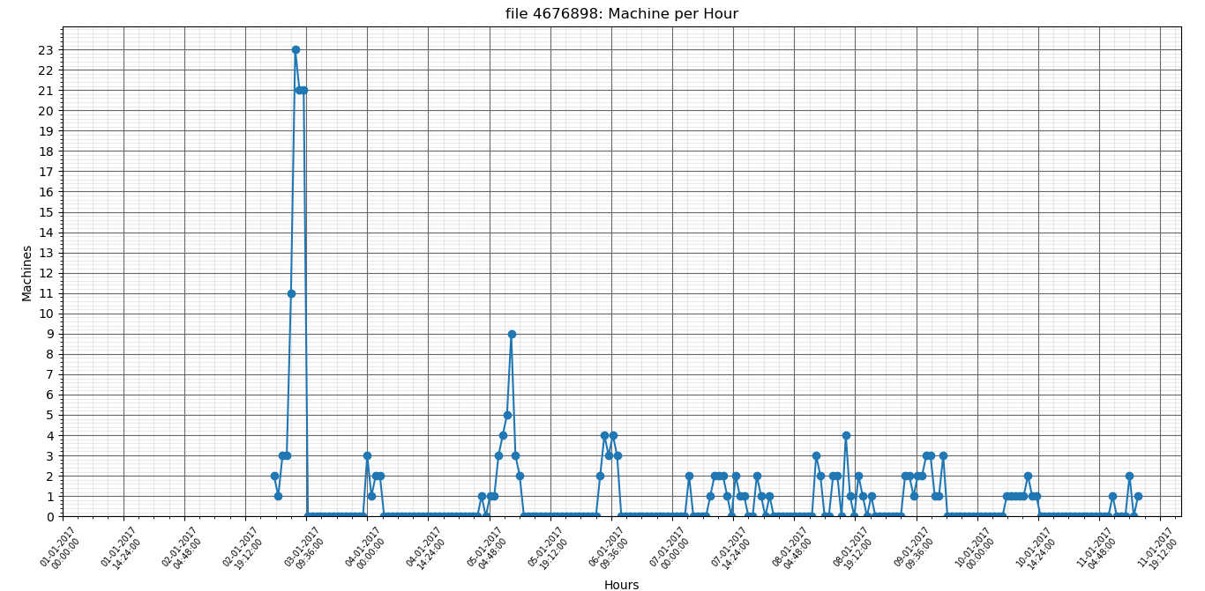

file 16467840: Average machine count per day is: 5.417

file 16467840: Standard deviation is: 9.986

file 4917916: Average machine count per day is: 2.500

file 4917916: Standard deviation is: 2.680

file 17755244: Average machine count per day is: 6.500

file 17755244: Standard deviation is: 7.441

file 16204627: Average machine count per day is: 7.500

file 16204627: Standard deviation is: 12.310  


file 8155252: Average machine count per day is: 2.083

file 8155252: Standard deviation is: 1.782

file 8679558: Average machine count per day is: 6.750

file 8679558: Standard deviation is: 9.659





file 5904604: Average machine count per day is: 2.833

file 5904604: Standard deviation is: 2.250

file 709801: Average machine count per day is: 4.333

file 709801: Standard deviation is: 7.050

file 17472453: Average machine count per day is: 11.083

file 17472453: Standard deviation is: 30.381

file 6726032: Average machine count per day is: 1.917

file 6726032: Standard deviation is: 6.640